Maple and Laurel’s class ideas for figurative language and fronted adverbials
Trees of death bend with each crackle in the sky
The moon was shining like a spotlight on the stormy sea
The grass was like millions of knives sticking into my feet
The tree is reaching out to grab your soul
The clouds mumbled as they emerged through the storm
A big bang from the ship crashing into the mountain
The clouds cry with rain tearing down
The gates are the entrance to your nightmares
The moon stared at me with a mischievous grin
The path is like a curving staircase
The horrible haunted house howled at me
At night, the midnight black crow cooed across the sky
The mountain whispered evil sounds
Creak! The gates slowly opened
The fence stood up like swords
The sky is as black as ink
The gruesome, green, grass whispered evil murmurs
The decapitated statue muttered to me to come
The path groaned with each step I took
The sea waves are as tall as skyscrapers
Smashing sea
The stormy, screaming sky
Aggressively, the gate slammed behind me
The moon was frowning down at me
Below the cliff,
The fireflies are shooting through the sky as fast as shooting stars
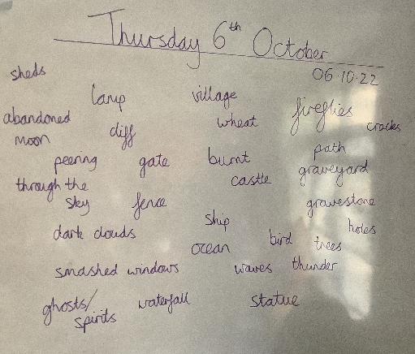
Trees sulking
Creepy cracks
Below my feet,
Terrifying trees
Spooky spirits
The moon peered through the sky
The trees gigantic arms reached out trying to grab my soul
Twice a year, the abandoned castle rises
Around the tree,
The wind howled
Down by the cliffs,
The air smelled like a heap of excretion
The road was a ribbon of moonlight
The rusty, old gates
Down by the cliffs, there is a demon waiting for someone
Walking through the gates of doom,
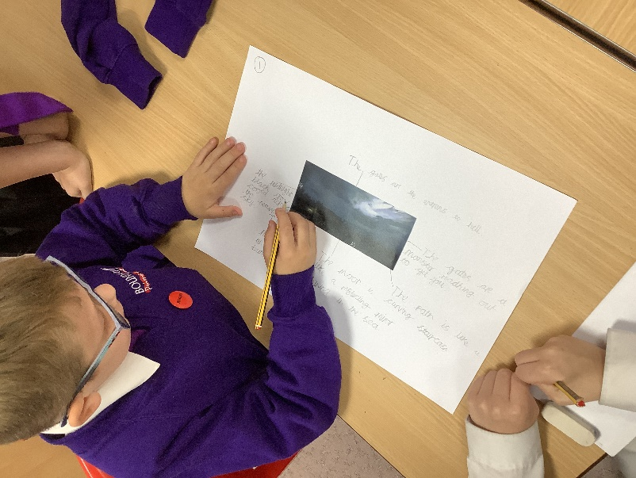
Dancing branches
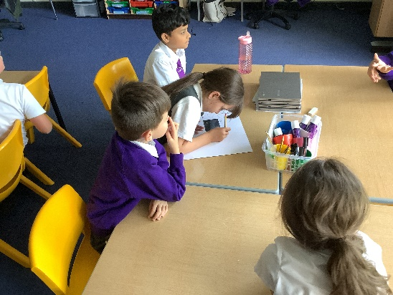
The trees bend over like a ballerina

